SUBCOURSE EDITION

QM6029 5

DIRECT RECEIPT OF
NONPERISHABLE SUBSISTENCE
SUPPLIES (101-502-2151)



DIRECT RECEIPT OF NONPERISHABLE SUBSISTENCE SUPPLIES

SUBCOURSE QM 6029
EDITION 5

United States Army Combined Arms Support Command
Fort Lee, VA 23801-1809

2 Credit Hours

REVIEWED: 1988

GENERAL

The Direct Receipt of Nonperishable Subsistence Supplies subcourse is part of the Subsistence Supply Specialist MOS 76X Skill Level 2 Course. It is designed to teach the skills and knowledge necessary for performing tasks related to receiving nonperishable subsistence supplies, verifying receipt of DD Form 1348-1 (DOD Single Line Item Release/Receipt Document), checking transportation document DD Form 1384 (Transportation Control and Movement Document), and recording data from receipt documents to DA Form 272 (Register of Vouchers to a Stock Record Account). The subcourse is presented in one lesson corresponding to the terminal learning objective as indicated below.

Lesson 1: DIRECT RECEIPT OF NONPERISHABLE SUBSISTENCE SUPPLIES

TASK: Direct receipt of nonperishable subsistence supplies.

CONDITIONS: An incoming shipment of nonperishable subsistence supplies has arrived. You must direct the unloading of these supplies.

STANDARDS: Demonstrate competency of the task skills and knowledge by correctly responding to the multiple-choice test covering directing receipt of nonperishable subsistence supplies.

(This supports SM Task 101-520-2151, Direct Receipt of Nonperishable Subsistence Supplies.)

Unless otherwise stated, whenever the masculine gender is used, both men and women are included.

i
TABLE OF CONTENTS

Section Page

TITLE PAGE. . . . . . . . . . . . . . . . . . . . . . . . . . . . .i

TABLE OF CONTENTS . . . . . . . . . . . . . . . . . . . . . . . . ii

INTRODUCTION TO DIRECT RECEIPT OF NONPERISHABLE SUBSISTENCE
SUPPLIES. . . . . . . . . . . . . . . . . . . . . . . . . . . . .iii

Lesson 1: DIRECT RECEIPT OF NONPERISHABLE SUBSISTENCE SUPPLIES

Learning Event 1: Direct Receipt of Nonperishable
Subsistence Supplies. . . . . . . . . . . . . . . . . . . . . 1

Practice Exercise . . . . . . . . . . . . . . . . . . . . . .14

Answers to Practice Exercise . . . . . . . . . . . . . . . . 16

ii
INTRODUCTION TO DIRECT RECEIPT OF
NONPERISHABLE SUBSISTENCE SUPPLIES

This subcourse explains the procedures for necessary control and documentation for receiving subsistence at troop issue subsistence activities (TISAs). The troop issue subsistence officer (TISO) determines receiving points, personnel authorized to receive nonperishable subsistence supplies, and methods of receiving nonperishable subsistence supplies. Proper receiving (identification and checking in) and control of receipt documents are essential to the TISA's accountability.

DIRECT RECEIPT OF NONPERISHABLE SUBSISTENCE SUPPLIES

In lesson 1, you will learn how to direct receipt of nonperishable subsistence supplies.

To understand how to direct receipt of nonperishable subsistence supplies, you must be able to:

1. Check (receipt and transporting documents) to make sure shipment is for your activity.

2. Record data from receipt document on DA Form 272 or locally devised tally register.

3. Direct spotting of carrier.

4. Assign personnel and obtain materials-handling equipment for unloading.

5. Direct unloading.

6. Direct tally-in of supplies.

7. Direct movement of supplies to holding areas.

8. Check blocks on receipt document.

9. Check the carrier for cleanliness (if government owned).

10. Notify the transportation office when the carrier is ready for release.

11. Release the carrier.

- Send receipt documents to the supervisor.

iii
Lesson 1/Learning Event 1

LESSON 1
DIRECT RECEIPT OF NONPERISHABLE SUBSISTENCE SUPPLIES

TASK

Direct receipt of nonperishable subsistence supplies.

CONDITIONS

An incoming shipment of nonperishable subsistence supplies has arrived. You must direct the unloading of these supplies.

STANDARDS

Demonstrate competency of the task skills and knowledge by correctly responding to the multiple-choice test covering directing receipt of nonperishable subsistence supplies.

REFERENCES

AR 30-18, Army Troop Issue Subsistence Activity Operating Procedures

TM 743-200-1, Storage and Materials Handling

FM 10-76X, Subsistence Supply Specialist

Learning Event 1:
DIRECT RECEIPT OF NONPERISHABLE SUBSISTENCE SUPPLIES

The troop issue subsistence officer (TISO) determines the areas where nonperishable subsistence supplies are received. He also determines which personnel are responsible for receiving subsistence supplies, which method is used, and how may persons are receiving a shipment.

Process DA Form 272

Use DA Form 272 (Register of Vouchers to a Stock Record Account) to record receipts and documents. Ensure this form is present at all receiving points and a tally number is assigned for each entry. All documents listed on DA Form 272 are verified weekly.

Methods of Receiving

The TISO designates all authorized receiving personnel on a DA Form 2496 (Disposition Form) (DF) and selects the method (blind count/two-person count) used to verify items shipped to each receiving point. Items are received on a DD Form 1348-1 (DOD Single Line Item Release/Receipt Document).

1
Lesson 1/Learning Event 1

Color Code

Prior to the movement of stock into storage, place a color identification on the bottom of each pallet load. Color is keyed to the month of receipt by assigning a specific color for each month.

Release Carrier

The transportation officer is notified when the carrier has been checked for loose subsistence items and cleanliness. The carrier is released by signing block 29, DATE RECEIVED-OFFERED (SIGN), of DD Form 1384 (Transportation Control and Movement Document).

Receiving Procedures

The TISO determines the number of receiving points to satisfy daily receiving requirements. Each location selected is published (in writing) and kept on file in the troop issue subsistence activity (TISA) office. One copy is furnished to appropriate supervisors to keep merchandise from being received at unauthorized locations.

The TISO appoints all receiving personnel in writing on a DA Form 2496 (figure 1) and gives a copy to the person appointed and his supervisor. All personnel within the TISA must be informed that to sign for subsistence supplies their names must be on a current DA Form 2496. The designated receiving personnel are not allowed to place orders with vendors. The receiver counts and verifies the items and quantities delivered. He prints his last name and signs his full signature on all receiving documents when completed.

2
Lesson 1/Learning Event 1

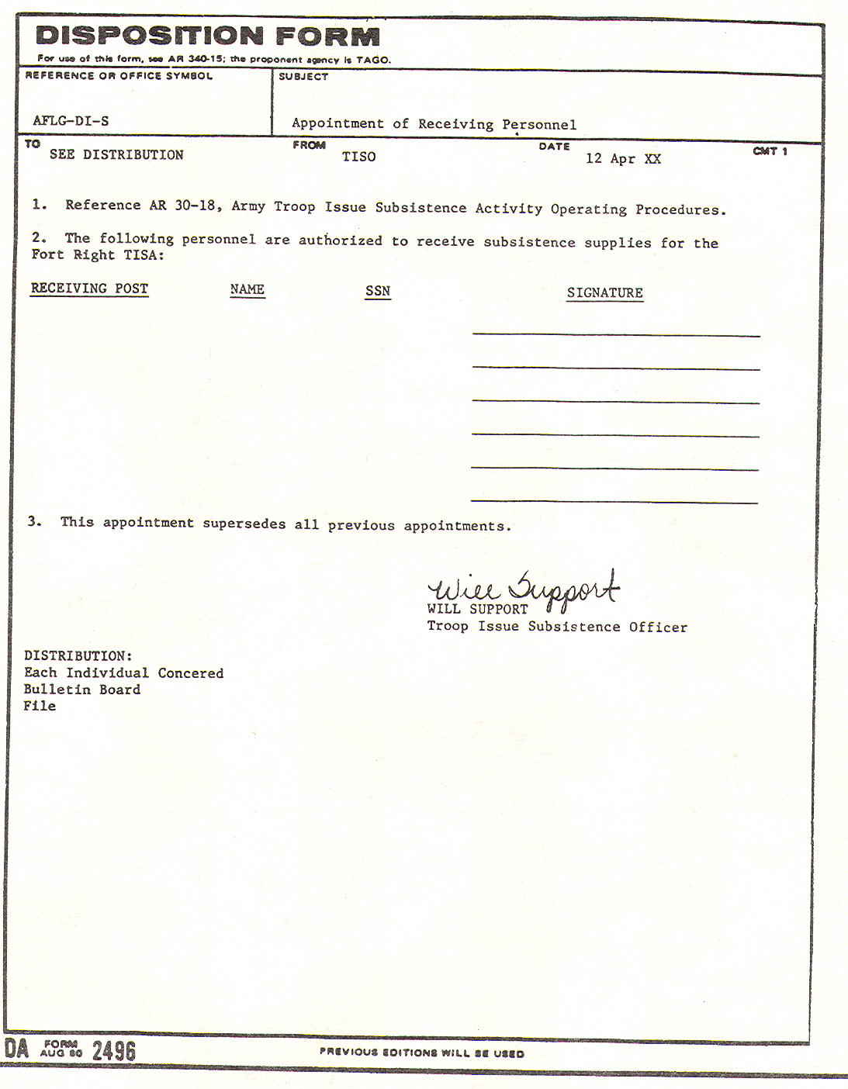

FIGURE 1. DA FORM 2496, DISPOSITION FORM, APPOINTING RECEIVING PERSONNEL.

3
Lesson 1/Learning Event 1

Planning and Coordinating Unloading of Nonperishable Supplies

The planning of receiving nonperishable supplies requires complete coordination among the storage activities responsible for the different phases of the operation. When a shipment arrives, the carrier is directed to the designated receiving point. This action is called spotting. Proper spotting results in a straight line flow, so that minimum travel distances and handling actions are necessary from the carrier to the receiving area or storage location. Continuous flow and proper balance between labor and equipment hold the loss of motion and waiting time for labor and equipment to a minimum. Each time a carrier is unloaded the supplies are tallied-in and inspected for damage. Also, they are counted on DD Form 1348-1 (figure 2).

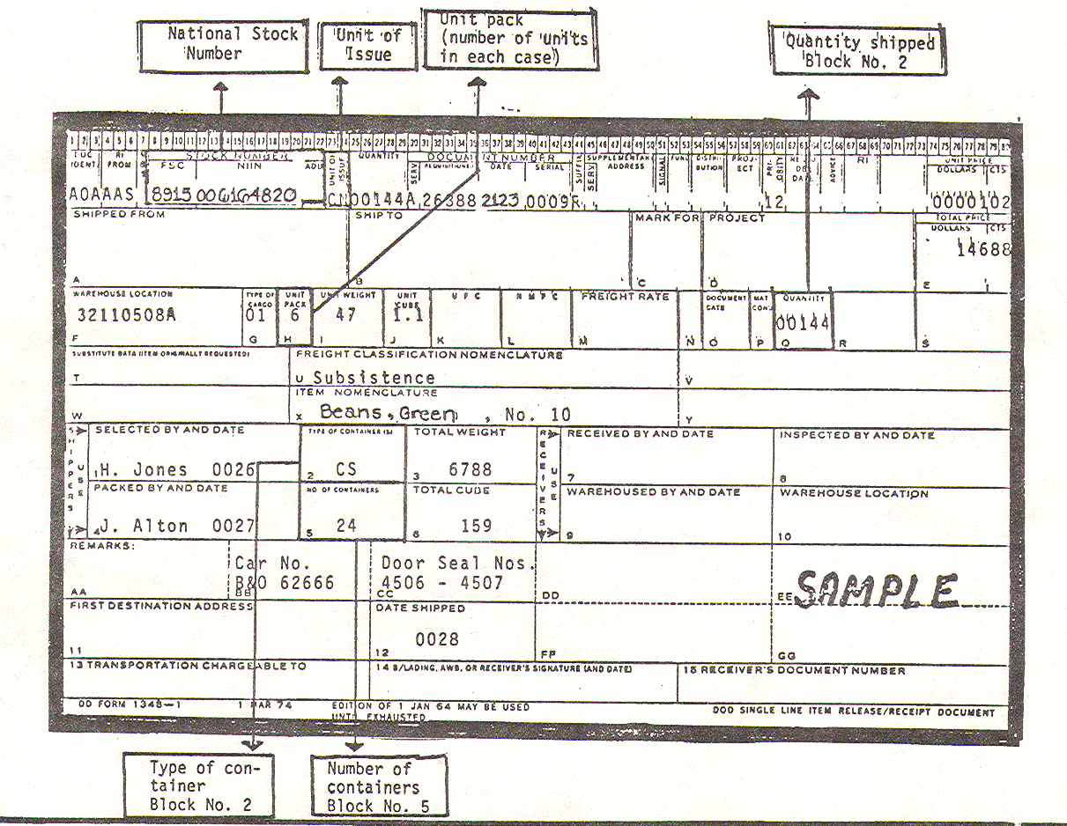

FIGURE 2. DD FORM 1348-1, DOD SINGLE LINE ITEM RELEASE/RECEIPT DOCUMENT,
SHOWING THE COUNT OF NONPERISHABLE SUPPLIES.

4
Lesson 1/Learning Event 1

Unloading Operations

Before a sealed truck or carrier is opened, the seal must be checked for its condition and serial number. If the seal is broken or missing or the serial numbers do not agree with the DD Form 1384 (figure 3), the transportation office is notified prior to unloading.

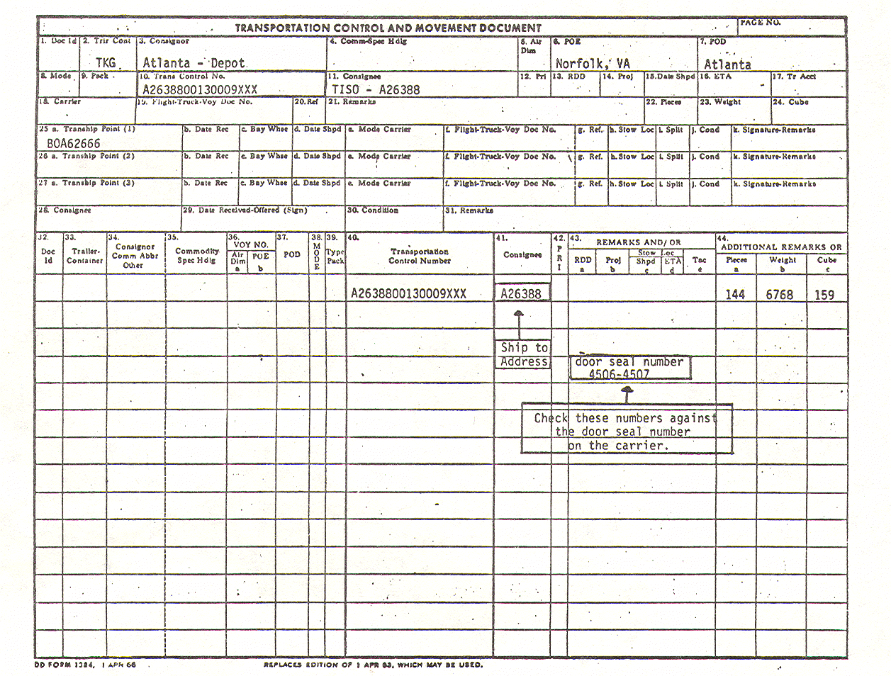

FIGURE 3. DD FORM 1348, TRANSPORTATION CONTROL AND MOVEMENT DOCUMENT.

Truck doors should always be opened so that personnel are protected against falling containers. Keeping the door between the person opening the door and the supplies is a safety precaution to keep anyone from being injured if cases should fall out. When the doors are open, the items should be visually inspected for shortage or damage. If there is obvious evidence of either, the unloading operation is stopped until the transportation officer inspects the contents. After inspection, unloading can continue.

5
Lesson 1/Learning Event 1

Tallying Incoming Subsistence Items

Items are tallied concurrently while they are being unloaded. DD Form 1348-1 (figure 4) can be used by lining through the numbers across the top of the form. Once unloading has begun, damaged containers should be set aside for later examination.

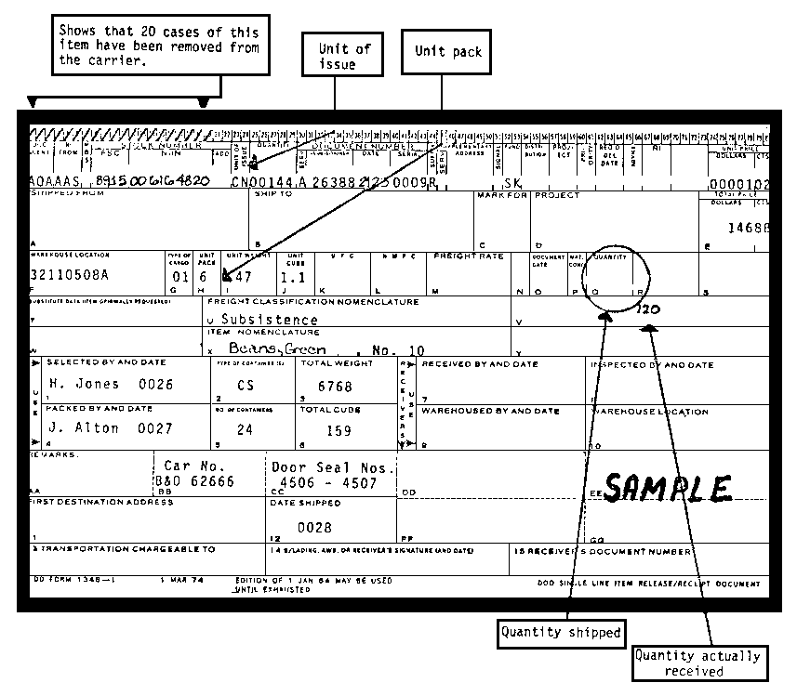

FIGURE 4. DD FORM 1348-1, DOD SINGLE LINE ITEM RELEASE/RECEIPT DOCUMENT,
SHOWING THE TALLY OF INCOMING SUBSISTENCE ITEMS.

6
Lesson 1/Learning Event 1

Methods of Receiving

The TISO should have a blind count used when practical. The blind count means receiving clerks do not know the quantities shipped and record on blind tally sheets. The tally sheets are forwarded to the administrative
section and the TISO, or his representative, verifies the quantity shipped is the same as received.

When the TISA's size, frequency of delivery, warehouse location, and personnel available indicate a need, the TISO establishes a two-person receiving rule. The two-person rule means there are two separate counts for each receipt. Both receivers individually count and verify the items and quantities delivered. They sign the RECEIVED BY and the INSPECTED BY and DATE blocks (figure 5). As individual line items are received and verified, they can be moved into storage. Nothing is moved from the receiving point until all units are accounted for or discrepancies documented. Only the number received is recorded on blind tally sheets (figure 6). For example, if 100 pounds were ordered and only 80 pounds were received, indicate 80 pounds on the order document. The storage location for each item is copied from the stock locator file. Once the location for each item is obtained, enter it on block 10 of DD Form 1348-1 (figure 7). Move each item to its designated location in the warehouse. Ensure the date of receipt is marked on one or more cases on the bottom layer of each pallet. Dates can be noted with felt tip markers. An alternative to using dates is a color coded system. Place a color identification on the bottom of each pallet load keyed to the month of receipt; i.e., black (January), orange (February), and red (March). Post a chart depicting the color code for each month near each warehouse receiving point. Marking the date of receipt/color code assists in proper rotation, preparing discrepancy reports, and conducting cyclic inspections by food inspectors.

7
Lesson 1/Learning Event 1

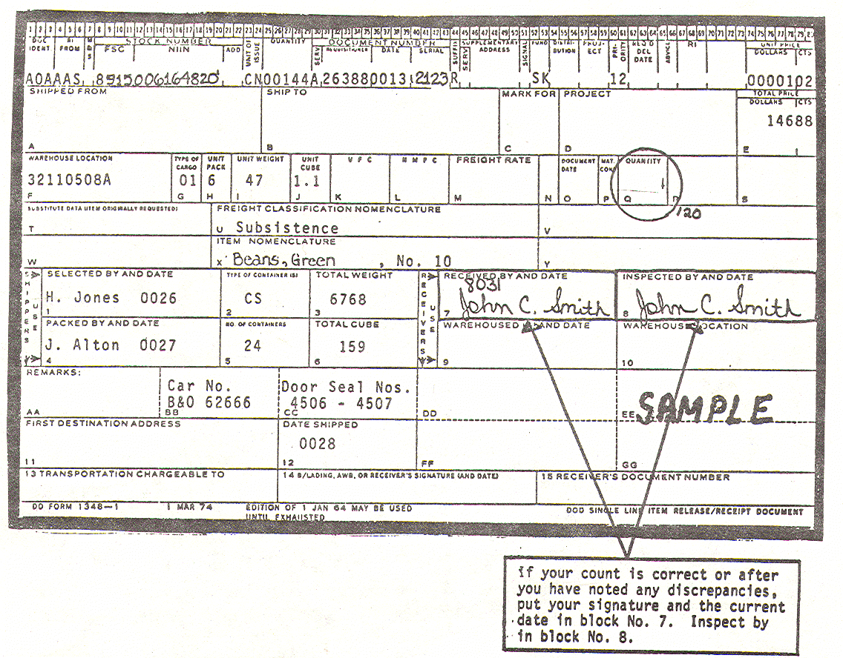

FIGURE 5. DD FORM 1348-1, DOD SINGLE LINE ITEM RELEASE/RECEIPT DOCUMENT,
SHOWING COMPLETED RECEIVED BY, INSPECTED BY, AND DATE BLOCKS.

8
Lesson 1/Learning Event 1

FIGURE 6. DD FORM 1348-1, DOD SINGLE LINE ITEM RELEASE/RECEIPT DOCUMENT,
SHOWING NUMBER OF ITEMS RECEIVED AND RECORDED ON A BLIND TALLY.

9
Lesson 1/Learning Event 1

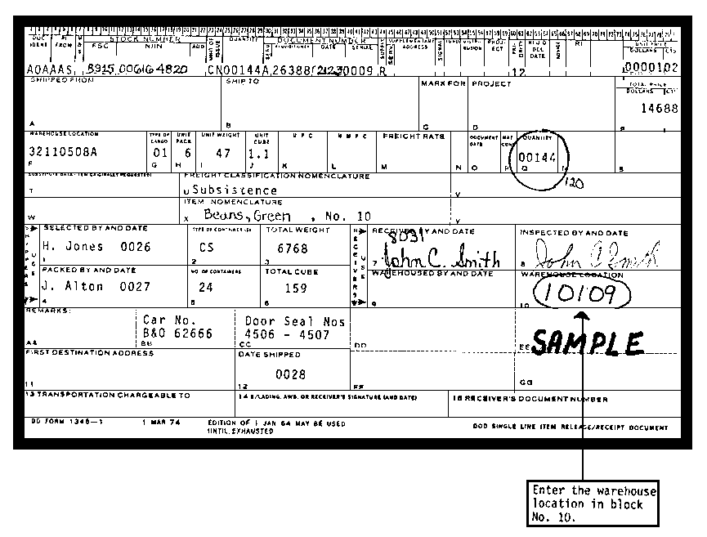

FIGURE 7. DD FORM 1348-1, DOD SINGLE LINE ITEM RELEASE/RECEIPT DOCUMENT,
SHOWING LOCATION OF ITEMS.

10
Lesson 1/Learning Event 1

Receipt Document Control

Control of receipt documents is critical. All receipts are recorded on a DA Form 272 (figure 8) and a form is kept at each receiving point. This form is completed by making the following entries:

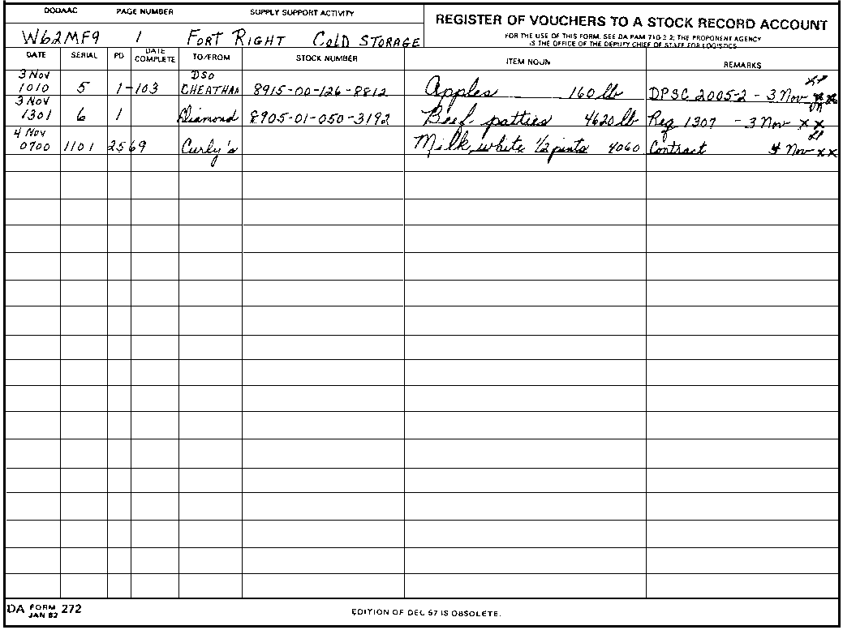

FIGURE 8. DA FORM 272, REGISTER OF VOUCHERS TO A STOCK RECORD ACCOUNT.

BLOCK INSTRUCTIONS

DODAAC Enter TISA Department of Defense Activity Address Code
(DODAAC).

PAGE NUMBER Enter page number.

SUPPLY SUPPORT Enter name of TISA and cold or dry storage.
ACTIVITY

11
Lesson 1/Learning Event 1

DATE Enter date and time of receipt.

SERIAL Enter voucher number or tally number for direct vendor
delivery items (such as bakery and dairy products)
received at the TISA warehouse.

PD Enter number of documents such as 1 or 103 or ticket
number of Department of Defense (DOD) items.

DATE Use this column, same as 6 above, if needed, or leave
COMPLETED blank.

TO/FROM Enter source of supply (SOS).

STOCK NUMBER Enter national stock number (NSN), continue SOS, or
leave blank.

ITEM NOUN Enter item noun of first item on the shipping document
and actual weight or number of cases of the total shipment.

REMARKS Enter any further identification of the document being
registered, such as requisition or purchase order
number, shipping document, damage or shortages, and
date paperwork is sent to the administrative office.
The authorized person enters his initials.

Receiving documents or delivery tickets are sent forward daily. Each set of documents may be by SOS and fastened together to prevent loss. All documents listed on DA Form 272 are verified weekly by the administrative section and the amounts clerk initials and dates the DA Form 272 when posting is accomplished.

Carrier is Unloaded

Before notifying the transportation office the carrier is unloaded and ready for release, remove the storage aids and clean the carrier (if government-owned). After notification, sign and date block 29 (figure 9) on DD Form 1384 to release the carrier and send all documents to the accounting office. TISA standing operating procedure (SOP) designates personnel authorized to hand-carry receipt documents to the administrative section.

12
Lesson 1/Learning Event 1

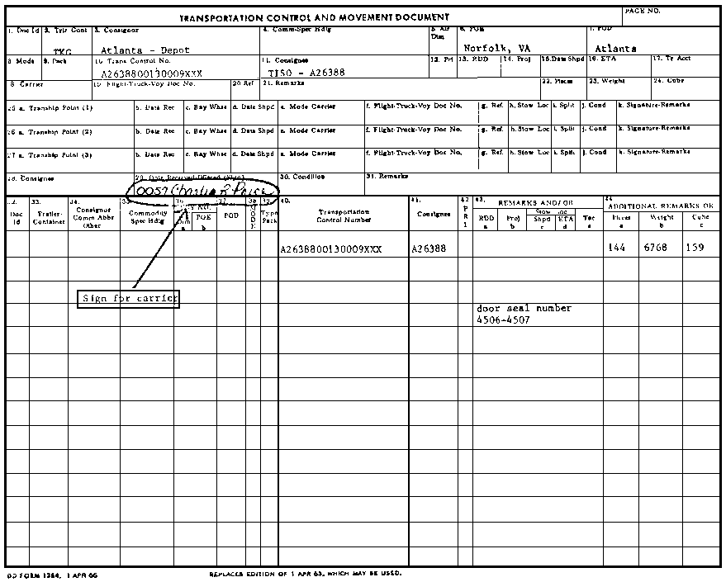

FIGURE 9. DD FORM 1384, TRANSPORTATION CONTROL AND MOVEMENT DOCUMENT.

13
Lesson 1/Practice Exercise

PRACTICE EXERCISE FOR LESSON 1

Instructions:

You have just finished reading the instructional material for lesson 1. This lesson covered directing receipt of nonperishable subsistence supplies. It is now time to check your understanding of the lesson. This is done by completing the practice exercise below. All of the questions are multiple-choice and are intended to measure your understanding of the procedures used in performing the task. There is only one correct answer to each question. Try to answer all of the questions without referring to the lesson materials.

When you have completed all questions, turn the page and check your answers against the correct responses. Each correct response is referenced to specific portions of the lesson material so that you can review any questions you have missed or do not understand. When you have completed this practice exercise, you should review all of the subcourse material before starting the posttest.

1. What is not checked on DD Form 1348-1 when verifying the receipt document?

a. The national stock number (NSN) and unit of issue (UI).
b. The unit of pack and quantity shipped.
c. The type of container and number of containers.
d. The unit cube and type of cargo.

2. What form is used to verify the seal found on the door of the carrier?

a. DD Form 1348 (Transportation Control and Movement Document).
b. DD Form 1348-1 (DOD Single Line Item Release/Receipt Document).
c. DA Form 272 (Register of Vouchers to a Stock Record Account).
d. DA Form 4170-R (Statement of Gains and Losses).

3. What form is used to record data from the receipt documents?

a. DD Form 1384 (Transportation Control and Movement Document).
b. DD Form 1348-1 (DOD Single Line Item Release/Receipt Document).
c. DA Form 272 (Register of Vouchers to a Stock Record Account).
d. DA Form 2496 (Disposition Form).

14
Lesson 1/Practice Exercise

4. What is meant by receiving with a blind count?

a. Receive shipment without counting items.
b. Two receivers will count individually.
c. Receivers do not know the quantities shipped.
d. Receivers will set damaged containers aside for later examination.

5. In what block is the location of supply items entered on DD Form
1348-1?

a. Block 9.
b. Block 10.
c. Block 11.
d. Block F.

15
Lesson 1/Practice Exercise Answers

ANSWER SHEET FOR PRACTICE EXERCISE

Lesson 1

1. d (Refer to Learning Event 1)
2. a (Refer to Learning Event 1)
3. c (Refer to Learning Event 1)
4. c (Refer to Learning Event 1)
5. b (Refer to Learning Event 1)

16

